**

Faculty of Computers and Artificial Intelligence

Computer Science Department

2021/2022

**CS 361 Artificial Intelligence in CS-1**

**N Puzzle Project**

|  |  |  |  |  |
| --- | --- | --- | --- | --- |
|  | ID | Name | Level | Department |
|  | 201900261 | Hossam Eldeen Sayed Ali | 3 | CS |
|  | 201900466 | Abdullah Mohamed Abdullah | 3 | CS |
|  | 201900576 | Kamel Ahmed Kamel | 3 | CS |
|  | 201900307 | Rana Abdelwahab Ali | 3 | CS |
|  | 201900899 | Nermeen Mamdouh Mohamed | 3 | CS |

Link of GitHub 🡪 <https://github.com/Abdullah3010/N-Puzzel/>

**Introduction and Overview**

* Project idea and overview:

An Intelligent N-Puzzle Solver using a Best-First Search algorithm.

The n-puzzle is a classical problem for modelling algorithms involving heuristics.

First, when we run the program, We Follow these steps:

- Choose N-puzzle size (8-Puzzle,15-Puzzle,24-Puzzle) ,

- Choose Type of heuristic and finally solve the Puzzle ( Solving it by Sort numbers from 1 to N and the empty cell in the last cell ).

* Similar applications:

(Web) 🡪 <https://github.com/igorgarbuz/n-puzzle>

It is an implementation of 15 puzzle game with an algorithmic solver and complexity analysis.

(Desktop) 🡪 <https://github.com/Faisal-AlDhuwayhi/AI-Solving-n-puzzle>

- Tool should accept n as input, along with the initial state.

- Initial state could be randomly generated as well.

- Tool allows user to select search strategy as input.

- Solve the problem using the selected search strategy.

* Academic papers:

1. Implementation and Analysis of Iterative MapReduce Based Heuristic Algorithm for Solving N-Puzzle.

(<http://citeseerx.ist.psu.edu/viewdoc/download?doi=10.1.1.651.3612&rep=rep1&type=pdf#page=182>) from page 182 to 186

1. Experimental Comparison of Uninformed and Heuristic AI Algorithms for N Puzzle Solution.

(<https://www.researchgate.net/publication/259694537_Experimental_Comparison_of_Uninformed_and_Heuristic_AI_Algorithms_for_N_Puzzle_Solution>)

1. Paper to explain how to solve N-Puzzle using search algorithms and the role of heuristics.

(<https://citeseerx.ist.psu.edu/viewdoc/download?doi=10.1.1.72.7748&rep=rep1&type=pdf>)

1. This paper show a goal base multi agent solution for the N-Puzzle problem. (<https://citeseerx.ist.psu.edu/viewdoc/download?doi=10.1.1.54.4301&rep=rep1&type=pdf>)
2. This paper "Evaluating Search Algorithms for Solving n-Puzzle" shows how the game is solved.

(<http://sumitg.com/assets/n-puzzle.pdf>)

* 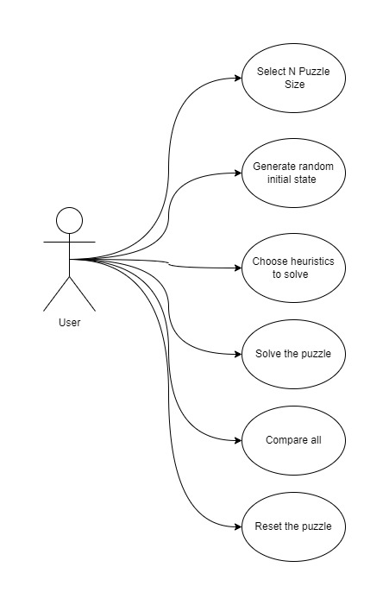Main functionalities:
* Algorithms (flowchart):

* Test and Compare results

Random state

Comparison of all heuristics and their solution path

* Development platform:
  + Programming language 🡪 Python.
  + Libraries 🡪 pygame, sys, random, pygame.locals, copy, operator.
  + Platform tools 🡪 Desktop application using Visual studio.
  + GUI 🡪 <http://inventwithpython.com/pygame/chapter4.html>
* Future Work

Why does the algorithm behave this way?

- To reduce the number of repetitions

What future modifications would you like to try when you solve this problem?

-The model chooses on its own the best heuristic functions